## A TE PROJECT REPORT ON

“**Water level indicator using Microcontroller 8051**”

Submitted by

# Vanshika Sable (Seat No.-T190343068)

# Rutuja Suryawanshi (Seat No.- T190343077)

# Rutuja Waghmare (Seat No.- T190343086)

Under the Guidance of

# Prof.R.M.Shamalik



**DEPARTMENT OF ELECTRONICS AND TELECOMMUNICATION ENGINEERING**

# BHARATI VIDYAPEETH’S COLLEGE OF ENGINEERING FOR WOMEN

**SAVITRIBAI PHULE PUNE UNIVERSITY, PUNE YEAR 2021-2022**



### CERTIFICATE

This is to certify that the TE Seminar report of

# “Water level indicator using Microcontroller”

Submitted by

# Vanshika Sable( Seat No.-T190343068)

# Rutuja Waghmare(Seat No.- T190343068)

# Rutuja Suryawanshi (Seat No.- T190343068)

## Of BE (Electronics & Telecommunication) is a bonafide work carried out by them under the guidance of **Prof.R.M.Shamalik** and it is approved for the partial fulfilment of the requirement of Savitribai Phule Pune University for the award of **bachelor’s** degree of **Engineering** in **Electronics & Telecommunication** of SavitribaiPhule Pune University at Bharati Vidyapeeth’ College of Engineering for Women, Dhankawadi , Pune-43

|  |  |  |
| --- | --- | --- |
| **Prof.R.M.Shamalik** |  | **Prof.Dr.S.R.Patil** |
| **Project Guide** |  | **Principal,H.O.D .E&TC** |
| **Place:Pune** |  |  |

### NDEX

|  |  |  |  |  |
| --- | --- | --- | --- | --- |
|  | **Sr.No** | **Title** | **Page**  **no** |  |
|  | 1 | Introduction | 6 |  |
|  | 2 | Literature Survey | 9 |  |
|  | 3 | Problem statement | 12 |  |
|  | 4 | Objectives | 12 |  |
|  | 5 | Methodology | 13 |  |
|  | 6 | Specification of the system | 14 |  |
|  | 7 | Block diagram of the system  Working | 16  17 |  |
|  | 8 | FlowChart | 18 |  |
|  | 9 | Hardware  design | 19 |  |
|  | 10 | Experimental Result | 20 |  |
|  | 11 | Simulation | 21 |  |
|  | 12 | Applications, future scope | 22 |  |
|  | 12 | Conclusion  Summary | 23  24 |  |
|  | 13 | References | 25 |  |

**ACKNOWLEDGEMENT**

The completion of any project brings it with it sense of satisfaction, but it is never complete without thanking those people who made this possible whose constant support has crowned our effort with success.

We would also like to thank our guide, **Prof.R.M.Shamalik**, department of Electronic and Telecommunication for the expert guidance, encouragement, valuable suggestions at every step and support towards the completion of project.

We avail this opportunity to express my sincere gratitude to all those people who contributed to this project .I am grateful to **Prof.Dr.S.R.Patil**, Principal and head of department for their continuous encouragement and support.

# Vanshika Sable ( Seat No.-T190343068)

# Rutuja Suryawanshi (Seat No.- T190343077)

# Rutuja Waghmare (Seat No.- T190343086)

### ABSTRACT

Now a days ,everybody has overhead tank at their homes, but the one who has a water tank above knows the kind of problems that they face. Water tank overflow is a common problem which leads to the wastage of water. Generally most of the houses depends upon the overhead tanks as the main source of water .People generally switch on the motor when their taps go dry and switch off the motor when the tank starts overflowing. This results in unnecessary wastage of water and sometimes non-availability of waterin emergency .This phenomenon is commonly seen in both Urban and rural areas and this needs controlled by monitoring water level in the tank, here we need a mechanism capable of switching on the motor when the water level in the tank goes low and switching it off as soon as the water level reaches a maximum level. Some of the advantages of Automatic water level control system in overhead tanks are Automatic system replaces human intervention and provides hassle free maintenance, prevents wastage of water, efficient usage of water and energy resources

### 1.INTRODUCTION

A Water Level Indicator may be defined as a system by which we can get the information of any water reservoir. Water level indicator system is quite useful to reduce the wastage of water from any reservoir, while filling such reservoir. Water is most essential thing on earth .Safe drinking water is essential to human and other life forms even though it provides no calories or organic nutriants. The total amount of water available on Earth has been estimated at 1.4 billion cubic kilometers, enough to cover the planet with a layer of about 3 km. About 95% of the Earth's water is in the oceans, which is unfit for human consumption. About 4% is locked in the polar ice caps, and the rest 1% constitutes all fresh water found in rivers, streams and lakes which is suitable for our consumption. A study estimated that a person in India consumes an average of 135 litres per day.

This consumption would rise by 40% by the year 2025. This signifies the need to preserve our fresh water resources . However, some observers have estimated that by 2025 more than half of the world population will be faced water based vulnearbility. The presence of water level indicator in reservoir can help control wastage and water indeaquacy in such reservoir. Water level indicator is used to show level of water in an over head tank, this keeps the user informed about the water level at all time avoids the situation of water running out when it is most needed. Indicators circuits have also alarm features. It not indicate amount of water present in overhead tank but also gives an alarm when tank is full. Advantages of the proposed water level controller are, very less maintenance, very low cost, very simple construction and the circuit involved is also relatively simpler. It can be easily made at home . After assembling the system, what remains is to observe its operation and efficiency. This can be done by breaking down the activity of the controller from the detection of water to the working of the pump. We go over the responses obtained when water reaches the sensors and the logic employed behind it. We also try to justify how a system as simple as ours can compete with those available commercially.

This is an interesting and very useful project in our real life. By using this project circuit, we can detect and control the water level automatically in a overhead tank or a container. This system monitors the level of water in a tank and automatically switches ON the motor whenever the water tank is empty. The motor is switched OFF when the overhead tank or container is FULL. Here, the water level of the tank is indicated on LCD (Liquid crystal Display). Using this system, we can avoid the overflow of the water.

In this system water sensing can be done by using a set of 4 wires which are placed at different levels in tank.

**2.LITERATURE SURVEY**

### Paper 1-

**Title -“**Design and Development of automatic water flow meter **”**

**Author-** Ria Sood, Manjit Kaur, Hemant Lenka

**Published Year-** June 2013

### Details-

This research paper by Ria Sood, Manjit Kaur, Hemant Lenka emphases on the need of water level controller in irrigation in agriculture. It says that every crop requires require different amount of water and this can be done by using automatic water level controller which will also help in reducing wastage of water. Here they use a technique to measure flow of rate of water in irrigation pipelines. It uses a Hall Effect Sensor to measure the rate flow. G1/2 Hall Effect water flow sensor is used as a sensing unit with a turbine rotor inside it whose speed of rotation changes with the different rate of flow of water.

### Paper 2-

**Title- “**Automatic Water Level Controller with Short Messaging Service (SMS) Notification**”**

**Author-** Sanam Pudasaini, Anuj Pathak, Sukirti Dhakal, Milan Paudel

**Published Year-**September 2014

**Details-**

This research paper by Sanam Pudasaini, Anuj Pathak, Sukirti Dhakal, Milan Paudel presents a system of an automatic water level controller with SMS notification. SMS notification was added to automatic controller system so that water can be managed by user during load shedding. Two systems work synergistically; automatic level controller system and SMS system. The program was developed in Arduino program developing environment and uploaded to the Microcontroller. Water level in the system is controlled automatically. The controller operates on a battery power. Whenever the system encounters empty level and the status of load shedding, the SMS notification is sent to the user. The system will automate the process by placing a single sensor unit in the tank that will periodically take measurements of the water level and will control the motor automatically. This system eliminates the efforts of people for daily filling of the tank and checks for overflow.

### Paper 3-

**Title- “**Automatic Water Level Control System **”**

**Author-** Asaad Ahmed Mohammed ahmed Eltaieb , Zhang Jian Min

### Published Year- 2019

**Details-**

This research paper by Asaad Ahmed Mohammed ahmed Eltaieb , Zhang Jian Min involves designing and development of automatic water level control system had exposed to the better way of software and hardware architecture that blends together for the interfacing purposes. The system employs the use of advance sensing technology to detect the water level. It uses Arduino and uses relay to control motor. Different wires are attached at different Junctions of the Beaker. When we pour water in the beaker. The water comes in contact with the wire and tells the level of water in the tank. Accordingly, they have displayed the level of water on LCD display. And uses relay to turn ON and OFF the motor

### Paper 4-

**Title**- “Echo based water level management system using 8051 microprocessor”

**Author-** Nagendra Pal Singh, Punit Gautam, Abhinandan Gupta

**Published Year-** June 2020

### Details-

Classical water management systems i.e water level indicators based on the principle of electrical conductivity of water, gives inaccurate or unreliable reading. To solve these issues this paper proposes the non contact water management system using ultrasonic technology and microprocessor 8051. This water level controller can monitor and control water tanks up to 2m deep and the accuracy of measuring is as low as 0.1cm.Since no mechanical float switches or electrodes are used here, there will not be any mechanical wearing or corrosion and this makes the system highly reliable. Any way proper care must be given to insulate the ultrasonic ranging module from damping as it contains a lot of electronics.

### 3.PROBLEM STATEMENT:

To notify the user the amount of water that is present in the overhead water tank

and don’t waste water .

### 4.OBJECTIVES

The following objectives are likely to be focused and achieved at the end of the project.

l) To create the most cost-effective and reliable water level controller using as less resources as possible.

2) To study the controller model and observe its characteristics.

3) To compare the controller with the conventional controllers available in market and find the advantages of the former over the latter.

4) To suggest any ideas or improvements that can lead to future development of the controller.

5) The control panel can also be programmed to automatically turn on a water pump once levels get too low and refill the water back to the adequate level.

### 5.METHODOLOGY

The Water Level Indicator employs a simple mechanism to detect and indicate the water level in an overhead tank or any other water container. Water Level Controller using [8051 Microcontroller](https://www.electronicshub.org/8051-microcontroller-introduction/) project will help in automatically controlling the water motor by sensing the water level in a tank. This article explains you how to detect and control the water level in an overhead tank or any other container. This system monitors the water level of the tank and automatically switches ON the motor whenever tank is empty.The motor is switched OFF when the overhead tank or container is FULL. Here, the water level of the tank is indicated on LCD (Liquid crystal Display). Using this system, we can avoid the overflow of the water.

**5.1Algorithm for water level controller**

* First configure the controller pins P3.0, P3.1, P3.2 and P3.3 as inputs and P3.4 as output.
* Initialize the LCD.
* If all the pins are low then display tank is empty on LCD and make P3.4 pin high to run the motor automatically.
* High pulse on the pin P3.0 indicates quarter level, display the same thing on LCD.
* If P3.1 is high then water level is half.High pulse on P3.2 indicates 3/4th full of the tank.
* If P3.3 is high then tank is full, make P3.4 pin is low to turn off the motor automatically.

### 6. SPECIFICATIONS OF THE SYSTEM:

* 1. **AT89C51:**

 AT89C51 is an 8-bit microcontroller and belongs to Atmel's 8051 family. ATMEL 89C51 has 4KB of Flash programmable and erasable read only memory (PEROM) and 128 bytes of RAM. It can be erased and program to a maximum of 1000 times.  In 40 pin AT89C51, there are four ports designated as P1, P2, P3 and P0. All these ports are 8-bit bi-directional ports, i.e., they can be used as both input and output ports. Except P0 which needs external pull-ups, rest of the ports have internal pull-ups. When 1s are written to these port pins, they are pulled high by the internal pull-ups and can be used as inputs. These ports are also bit addressable and so their bits can also be accessed individually. Port P0 and P2 are also used to provide low byte and high byte addresses, respectively, when connected to an external memory. Port 3 has multiplexed pins for special functions like serial communication, hardware interrupts, timer inputs and read/write operation from external memory. AT89C51 has an inbuilt UART for serial communication. It can be programmed to operate at different baud rates. Including two timers & hardware interrupts, it has a total of six interrupts.

An 8051 microcontroller comes bundled with the following features −

* 4KB bytes on-chip program memory (ROM)
* 128 bytes on-chip data memory (RAM)
* Four register banks
* 128 user defined software flags
* 8-bit bidirectional data bus
* 16-bit unidirectional address bus
* 32 general purpose registers each of 8-bit
* 16 bit Timers (usually 2, but may have more or less)
* Three internal and two external Interrupts
* Four 8-bit ports,(short model have two 8-bit ports)
* 16-bit program counter and data pointer
* 8051 may also have a number of special features such as UARTs, ADC, Op-amp, etc.

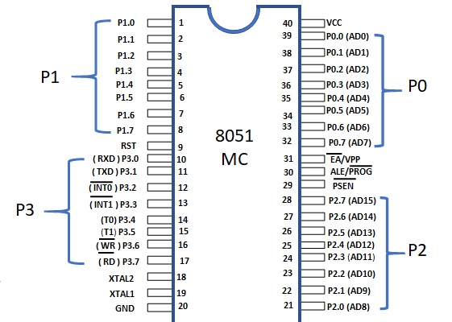

**Fig 1. Pin configuration of 8051**

### 6.2 LCD (Liquid Crystal Display)

LCD (Liquid Crystal Display) screen is an electronic display module and is very commonly used in various devices and circuits. These modules are preferred over seven segments and other multi segment LEDs. The reasons being: LCDs are economical; easily programmable; have no limitation of displaying special & even custom characters (unlike in seven segments), animations and so on.

A 16x2 LCD means it can display 16 characters per line and there are 2 such lines. In this LCD each character is displayed in 5x7 pixel matrix. This LCD has two registers, namely, Command and Data.

### The command register stores the command instructions given to the LCD. A command is an instruction given to LCD to do a predefined task like initializing it, clearing its screen, setting the cursor position, controlling display etc. The data register stores the data to be displayed on the LCD. The data is the ASCII value of the character to be displayed on the LED.

### Features of LCD:

* The operating voltage of this display ranges from 4.7V to 5.3V
* The display bezel is 72 x 25mm
* The operating current is 1mA without a backlight
* PCB size of the module is 80L x 36W x 10H mm
* HD47780 controller
* LED color for backlight is green or blue
* Number of columns – 16
* Number of rows – 2
* Number of LCD pins – 16
* Characters – 32
* It works in 4-bit and 8-bit modes
* Pixel box of each character is 5×8 pixel
* Font size of character is 0.125Width x 0.200height

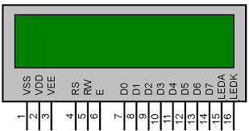

**Fig 2. LCD**

### 7.BLOCK DIAGRAM:

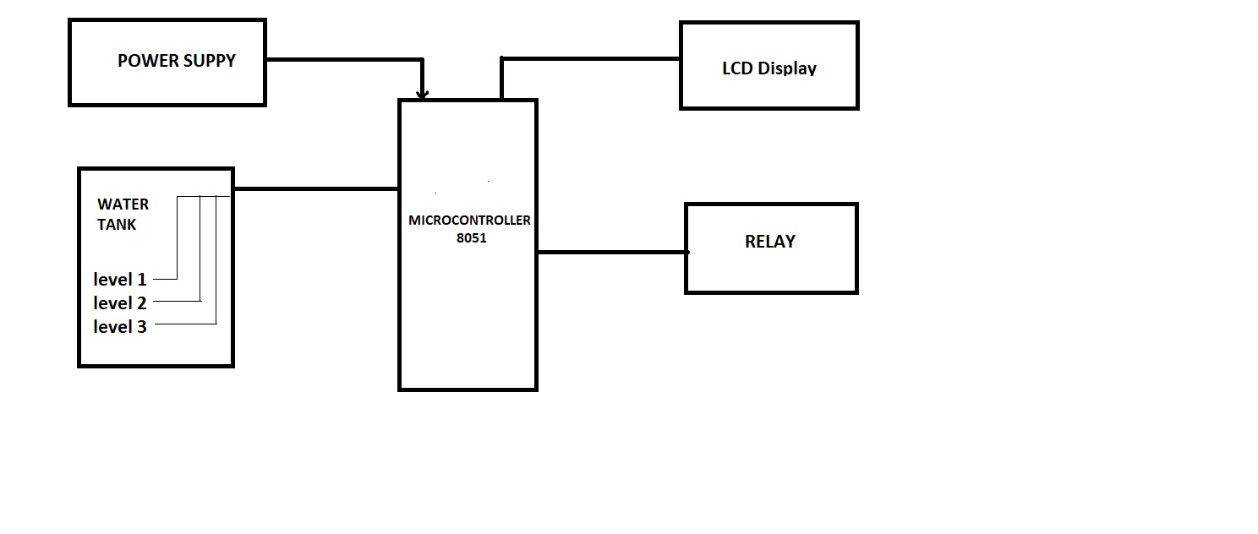

**Fig 3.-Block Diagram**

**7.1Components :**

* At89c51 controller
* Capacitor
* Diodes
* Crystal
* 16*2 LCD
* 5V Relay
* Bc547 (NPN) transistors
* 5Resistors (1K)
* 4Resistor 330 ohm
* Connecting wires
* Power supply

### 8.WORKING:

* Using 8051The main heart of this project is AT89C51 microcontroller.
* The water level probes are connected to the P3.0, P3.1, P3.2, and P3.3 through the transistors.
* Port P2 connected to the data pins of LCD and control pins RS, RW and EN of LCD are connected to the P1.0, P1.1, and P1.2 respectively.
* Initially when tank is empty, LCD will display the message EMPTY and motor runs automatically.
* When water level reaches to quarter level, now LCD displays QUARTER and still motor runs.
* For further levels, LCD displays the messages HALF and FULL.When tank is full, LCD displays FULL and motor automatically stops.
* Again motor runs when tank is empty.

### 9.FLOW CHART :

### 

**Fig.4** Flow Chart of the system

### 10DESIGN

* 1. **Hardware design:**

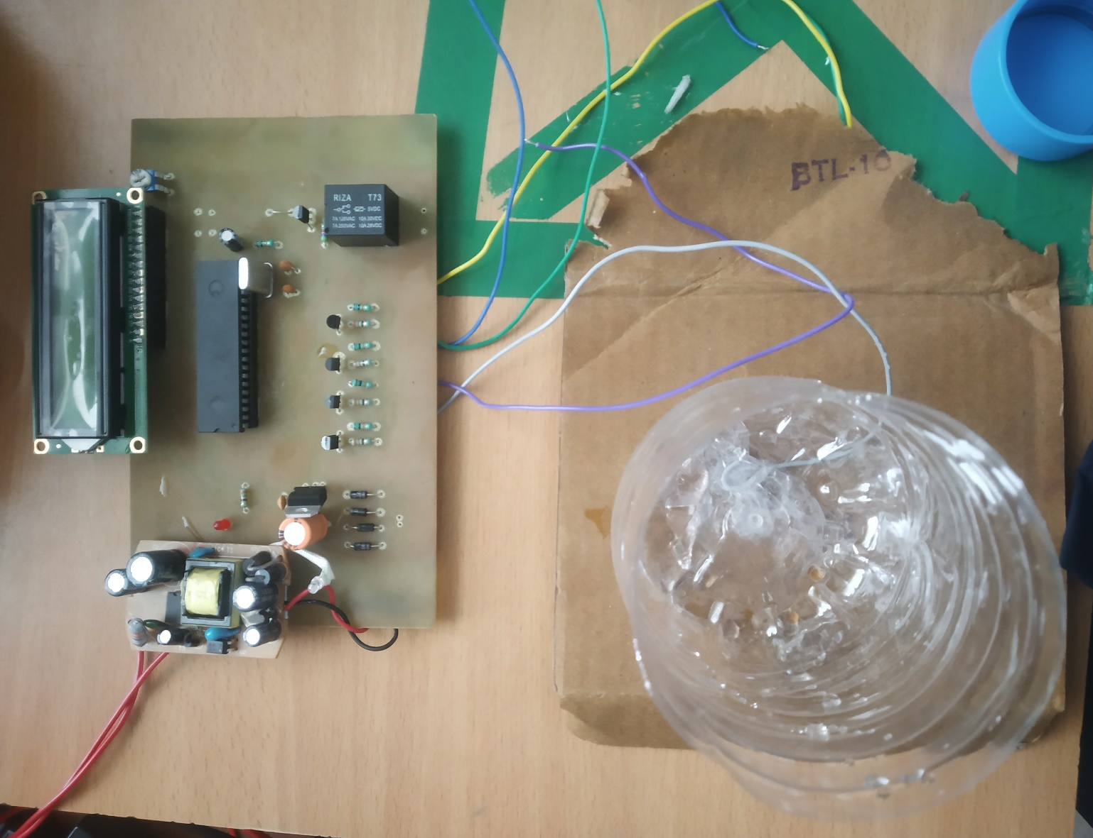

### 11. EXPERIMENTAL RESULT

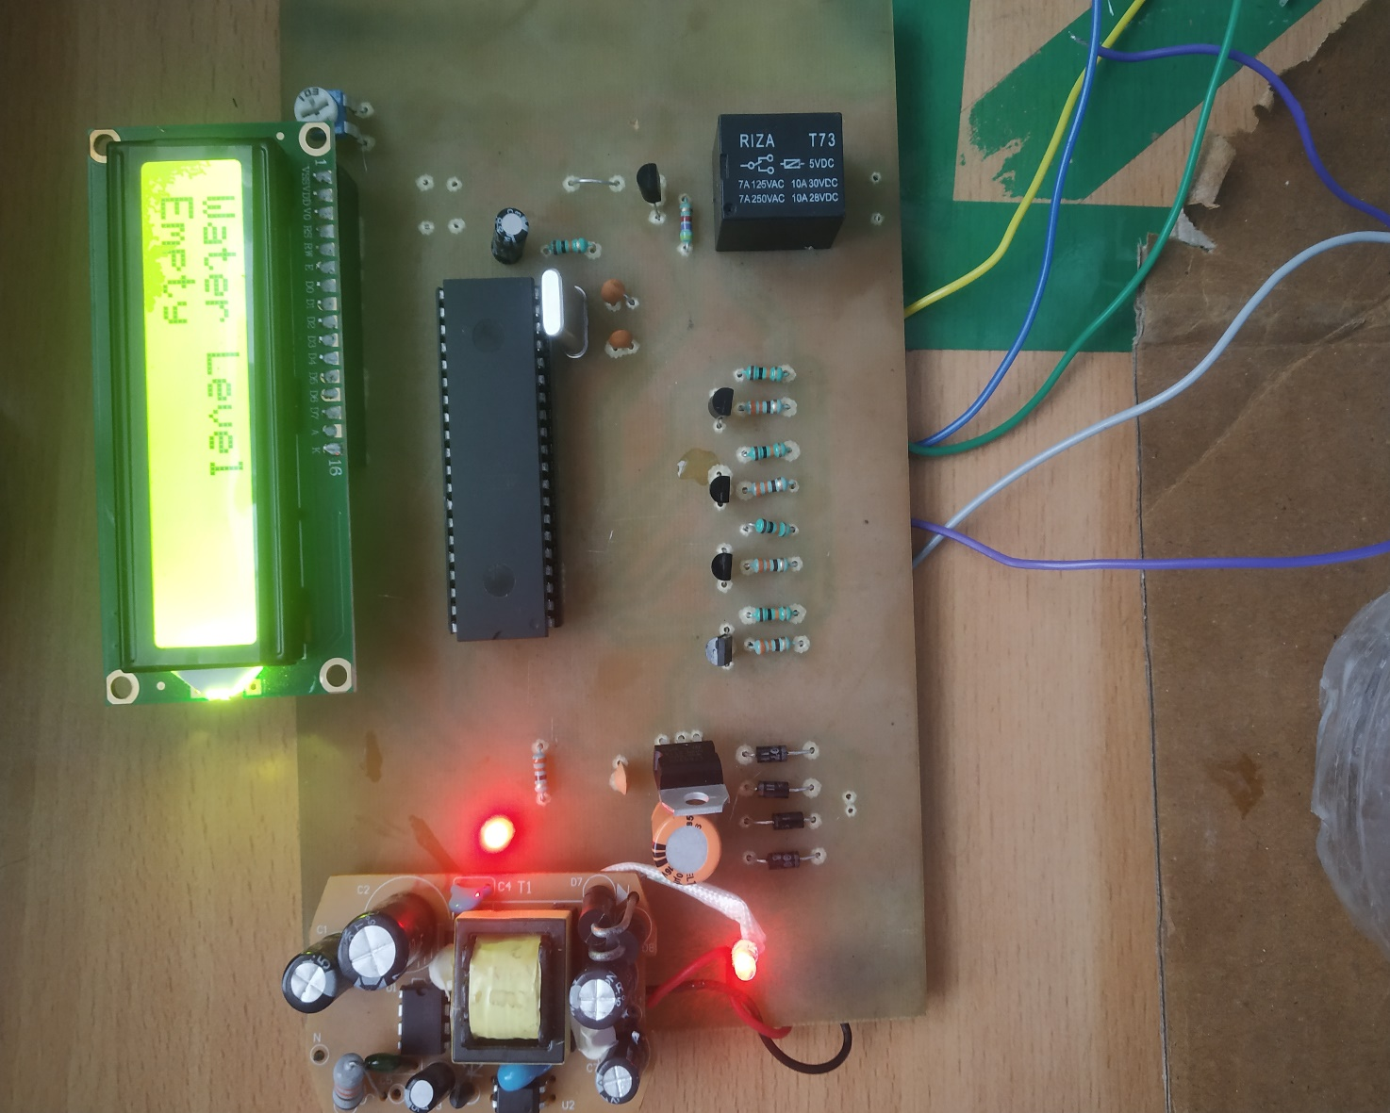

**12. SIMULATION**

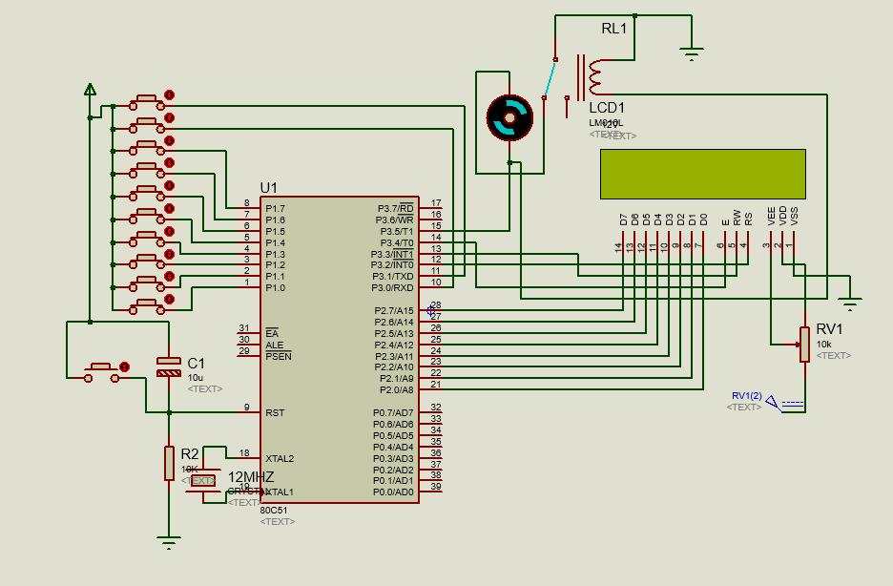

### Fig.7 SIMULATION

**13.1 ADVANTAGES:**

• Human effort is reduced as the system controls the motor automatically based on

the water level.

• This system consumes less power.

• Simple and more reliable.

**13.2 APPLICATIONS:**

• Automatic Water level Controller can be used in hotels, factories, homes

apartments, commercial complexes, drainage ,etc.

• It will automatically START the pump set as soon as the water level falls below the

predetermined level and shall SWITCH OFF the pump set as soon as tank is full.

• Fuel level indicator in vehicles.

• Liquid level indicator in huge containers in the companies.

**13.3 FUTURE SCOPE**

In future, we want upgrade this circuit with some sensor which can automatically stop the power supply of the driving pump or motor. As a result the future circuit is not very cheaper the the present one, but we try our best to

• Make it simple.

• Easy to use.

• Easy to install.

• To make Available for all.

• Try to smaller than the present one.

As a result it can available.

**14. CONCLUSION:**

Automatic water pump control system employs the use of different technologies in its design, development, and implementation the system used microcontroller to automate

the process of water pumping in an over-head tank storage system and has the ability to

detect the level of water in a tank, switch on/off the pump accordingly and display the

status on an LCD screen. This research has successfully provided an improvement on

existing water level controllers by its use of calibrated circuit to indicate the water level .

### 15. SUMMARY:

In this Project water level indicator using microcontroller 8051 it proposed The water level Indicator employs a simple mechanism to detect and indicate the water level in an over head tank or any other water container. The sensing is done by using a set of four probes which are placed at four different levels. We can conclude that this system is very beneficial in rural as well as urban areas. It helps in the efficient utilization of available water sources. If used on a large scale, it can provide a major contribution in the conservation of water for us and the future generations. In these days, when the Earth's reserve of consumable water is decreasing every moment, every drop has its value. Water level controller is a simple yet effective way to prevent wastage of water. Its simplicity in design and low cost components make it an ideal piece of technology for the common man.

1. **REFERENCES**

[1]https://en.wikipedia.org/wiki/Intel_8086

[2] integrated electronic.blogspot

[3] https://www.youtube.com

[4] <https://blog.feedspot.com/electronics_blogs/>

[5] www.google.co.in –Google

[6] Joydeep Kumar Chakraborty, “Water Level Controller”

[7] Rex Niedermeyer, "Aquarium Water Pumps"